|  |  |  |
| --- | --- | --- |
| **LAB221 Assignment** | **Type:** | **Long Assignment** |
| **Code:** | **J2.L.P0001** |
| **LOC:** | **200** |
| **Slot(s):** | **10** |

**Title: Simple Graph Visualization Software (sGraphviz)**

**Background**

Graph visualization is a way of representing structural information as diagrams of abstract graphs and networks. It has important applications in networking, bioinformatics, software engineering, database and web design, machine learning, and in visual interfaces for other technical domains.

In mathematics, and more specifically in graph theory, a graph is a representation of a set of objects where some pairs of objects are connected by links. The interconnected objects are represented by mathematical abstractions called vertices (also called nodes or points), and the links that connect some pairs of vertices are called edges (also called arcs or lines). Typically, a graph is depicted in diagrammatic form as a set of dots for the vertices, joined by lines or curves for the edges.

**Program Specifications**

The **Simple Graph Visualization Software (sGraphviz)** is a small program that helps user to draw a directed graph. The graph description is written in a very simple graph description language. The graph description includes 02 parts. The first part is a list of vertices. Each vertex has label, and color attributes. The second part is a list of edges. Each edge has direction (A->B: Vertex A to Vertex B) and label. From the graph description, the **sGraphviz** can visualize the graph and save it in an image file.

**For example**: A traffic light graph

Graph description:

TrafficLight {

//vertices

R [label="RED", color="red"]

G [label="GREEN", color="green"]

Y [label="YELLOW", color="yellow"]

//Edges

R->G [label="45"]

G->Y [label="65"]

Y->R [label="5"]

}

From the graph description above, the **sGraphviz** can visualize the graph, it looks like.

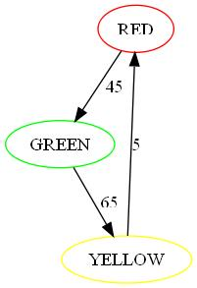

**Features:**

-A text editor for user to type the graph description

* New function: Create a new graph description file
* Open function: Open an existing graph description file
* Save function: Save a graph description to text file

(New, Open, Save functions are grouped in File menu item)

-A function to visualize the graph

-A function to save the graph to image file.

***Expectation of User interface:***

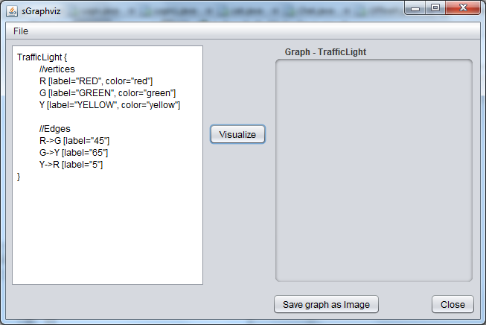

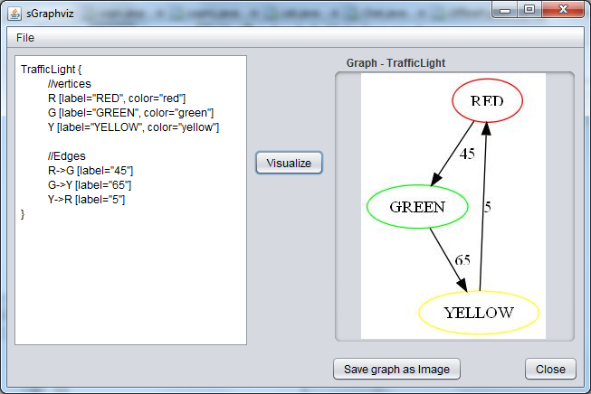

**Guidelines**

* Use Canvas component to draw graph.
* Save image in canvas to file solution:

